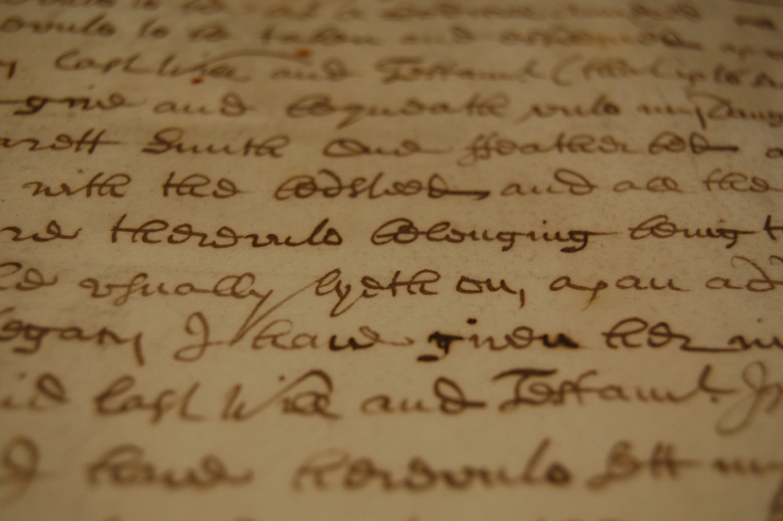
Peter Tyas and Claire Skinner
2013
Artists in the Archives Toolkit version 1.0

Wiltshire and Swindon History Centre,
Cocklebury Rd, Chippenham SN15 3SP
Tel 01249 705500

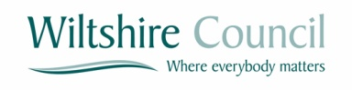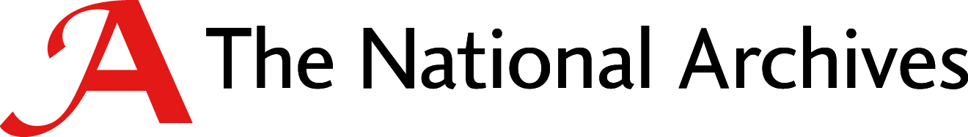

Introduction
“My argument is that history is made by men and women, just as it can also be unmade and rewritten, always with various silence and elisions, always with shapes imposed and disfigurements tolerated.”
Edward W. Said

This toolkit is being developed to support archivists and artists to work together. The content of this toolkit has been draw from practical experience and the evaluation of projects over the past 12 months.
The toolkit is divided into three sections:
- Developing a Good Working Relationship
- Additional Areas of Interest and a Guide to Using Archives
- Towards A Collaborative Method (in progress)

Developing a Good Working Relationship

This section of the tool kit is intended to help archivists and artists to communicate more effectively by growing the understanding of one another’s ways of working.
Methods
All artists have a working method unique to themselves; the method an artist uses may vary between projects and even within the stages of a project.
Artists should be able to articulate their method and it may be helpful to write this down and discuss at the outset as a part of the project plan.
Artists may be interested in archival processes and methods of work, as well as the legal framework within which materials are collected and retained.
Archivists: Don’t be reluctant to describe the detail of how you work and why you work in a certain way. Some artists may be just as inspired by you, your work and your career as by the archives that you are working with.
Artist: Don’t be reluctant to ask questions but be prepared to do your own research. Don’t forget that more than one repository may hold interrelated materials so you may need to contact several archivists. Archivists are well used to collaborative working and may be able to help you to find usual and little used materials.
Inspiration and Decision Making
All artists seek inspiration as a starting point; this is often found in the smallest detail, oblique remark or even the absences that archivists find frustrating.
Artists should be able to describe what they are looking for, even if that is only in the vaguest of terms. Don’t be surprises if the search for inspiration or the inspiration found changes the project, repeatedly, and or completely.
It is always useful to establish at the outset whether the project will be ‘artist led’ and will follow the inspiration or whether the funding and stakeholders have committed to something specific that must be delivered.
It is always useful to agree how decisions will be made within the project; often this is tied to the funding and the level of in kind support required to deliver the project.
Archivists: Make sure you are clear from the outset what you are hoping to get from the project and how decisions will be made during the life-time of the project.
Artists: Make sure that you communicate what you have found and how you plan to use it throughout the delivery of the project.
Project Management
All projects require clear management and all collaborations require a shared understanding of what each party is committing to the project. If there is external funding involved then the accountable body (who has received the funding) must be confident that they are able to deliver the requirements of the funder. This should be agreed through a dialogue and confirmed through a letter of appointment or a letter of support. Where there is no external funding there is still a commitment of time and potential in kind support (for example room space) and this should be agreed by both parties at the outset.
The project lead should issue a letter of appointment or gain a letter of support to summarising the project, key milestones and what resources are being committed. This letter should describe what the end result of the project is and who is responsible for delivering what.
Archivists: Always speak with the artists at the outset of the project and produce a letter of appointment (this is useful even when there is no funding changing hands as it will describe the extent of your commitment and how involved you will be in the management of the project).
Artist: Always speak with the archivists before submitting a funding bid to make sure that they have the time and the resources you require. Always seek a letter of support from the archive to ensure that you understand the level of commitment that you can expect from the archive.
Intention and Expectations
All artists create work with the intention of making a statement and eliciting a response; even if this response is out with the original intention of the artist. There should be a discussion at an early stage to explore what the intention of a work might be and how your audience might respond to what the artist is proposing.
All artists want to have clarity on what is expected of them and the work that they create. The creative potential and the enthusiasm that artists have for the subject can often exceed the capacity available within the project to deliver all that is discussed. It is always helpful to have an agreed output which is discussed throughout the development of the project and at key milestones within the delivery of the work.
Archivists: Don’t be reluctant to challenge what is being proposed, though this discussion will be more fruitful at the early stages of a project when there is still room to adapt the outputs.
Artists: Don’t avoid the conversation about how your work will be seen by the public, especially when the work will be displayed in an archival setting.
Communication and Use of Language
Communication is an essential part of all projects and partnerships. Most artists want to have clarity around the expectations of their work and it can be helpful to draft up a ‘working agreement’ which outlines the methods and regularity of communication. For example: will there be regular meetings or e-mail updates to monitor the delivery of the project and who will be responsible to for all these meetings and how much time can each party offer?
The creative process requires a great deal of trust on both sides; this trust is based upon clear communication and shared objectives. Both artists and archivists use words with specific and often technical meanings and it may be helpful to focus upon this use of language at an early stage.
Communication with the public may be an essential part of the project; through social media or exhibition / performance catalogues. It may be important to get additional support to make sure that this out going communication is produced in a style appropriate to the audience. It may also be important to preserve the language of both archivists and artists. This should be discussed throughout the project, particularly as audience / community feedback becomes available.
Archivists: Don’t be afraid to ask for a translation or to challenge the way that artists describe their work and the archival materials they have used.
Artists: Don’t be afraid to ask for a translation or to challenge the way that archivists describe their work and the archival materials they have suggested and the way they have interpreted them.
Integrity, Editing and Boundaries
All artists produce their work as expressions of themselves or a facet of their creative identity. The integrity of the work is as important as the authenticity of the archival materials used. There is scope for this to be explored within projects and it is potentially a rich source of inspiration.
All projects go through a process of refinement and editing; it is essential that that there is agreement at the outset about the artistic decision making. This is often defined by the status of the project as either ‘artist led’ or ‘commissioned / stakeholder led.’ Normally there is a degree of flexibility required between the parties to ensure that the artist is able to retain the integrity of the work whilst delivering the specifications of the stakeholders and funders.
Some projects may engage with subjects, archival materials or communities which require a high degree of sensitivity. It is often useful to define the boundaries of a project to ensure that current working relationships are not jeopardised by the project.
Archivists: Always ensure that there is agreement at the outset on who is responsible for selecting work for display or presentation to the public. Always ensure that you are clear where there is a legal or moral issue with an archive and ensure that the artist is aware of the statutory requirements for the use and retention of personal information.
Artist: Always ensure that there is clarity on the boundaries within which the work is being created; and be aware that there may be legal considerations when collecting new archival material or using existing personal information.
Ambiguity, Knowledge, and Insights
Artists are often happy to allow ambiguity to persist throughout a project as this allows for change, chance and originality. It is essential to acknowledge where ambiguity exists, where it can be allowed to continue and where it must be clarified. Sometime ambiguity allows for a better project to occur and in some cases for the greater outcomes to be addressed at the cost of some of the planned outputs. For example, the intended outcome might be to engage the travelling community in using the archive but the selected output of a publication may prove to be more of an obstacle than a solution. At this point it is important to reassess the project and decide whether the exhibition (output) is more important than engaging the community (outcome).
It is essential to agree what is more important, the agreed outputs or the overall outcomes - and how these outcomes will be measured if not by the delivery of the original outputs.
Artists and archivists will bring knowledge to a project and through working together create new insights. Archivists will have a deep understanding of elements of their collections as well as a firm grasp on how to explore the whole. It is also highly likely that they will know other people who have researched areas that they are not familiar with. Many archivists will have specialist thematic or temporal knowledge; for example agricultural history over a long span of time or in-depth knowledge of a particular century.
Artists are often drawn into study through fascination and inspiration and may have absorbed a great deal of knowledge about specific subjects. It can be important for the authenticity and integrity of the project to explore what is known by both parties and for further research to be undertaken to ensure that the culture and context of archival materials are understood within the creative process.
Archivists: Seek to address concerns over ambiguity at the outset and be prepared to share your knowledge or provide access to appropriate resources.
Artists: Seek to preserve the ambiguities that you need to allow for creativity but also accept where clarity is required. When working with archives it is just as important to be clear on what you are trying to do as it is be clear on what you think the archives are telling you.

Additional Areas of Interest and a Guide to Using Archives

Archives sit within a network of history groups, researchers and community projects. Archivists are well used to working in regional and national networks and have strong connections with specialist societies and organisations. All of these connections may be of interest to artists and it may be worth opening up a wider conversation to allow for a project to expand into unexpected places.
Artists are often drawn to specialists for the language that they use as well as the knowledge that they hold. Many artists find inspiration through immersion within societies and groups, through seeing the world through the eyes of others.
Artists will often develop a deep connection or fascination with a subject whilst they are undertaking research and developing a creative response. They will often be willing to read around a subject and may even appreciate a reading-list or similar suggested further reading.
Archivists: Be prepared to give time and thought to work with the artist. The more time and preparation that you put into meeting and discussing the work the more rich and authentic the artist’s response will be.
Artists: Be prepared to provide background information on what your practice is and why you are requesting access to groups or individuals.
Using archival catalogues
- Verbal not visual
Given the volume of archives held (many thousands, even millions, of individual items in some cases) it is not usually possible to ‘browse’ an archive visually to see what it contains. It is essential to use a written catalogue created by an archivist which describes the archive verbally instead. This can act as a barrier to some types of use (eg only wanting to look at books bound in parchment covers, for example) as the catalogues are written with specific types of use in mind. The normal procedure is that the researcher checks the catalogue or index, identifies the item they wish to see, then orders it up using a manual or computerised ordering system – a bit like the ‘Argos’ catalogue! The repository staff will then bring them the document to use, and will put it away again when it is finished with. It is worth checking with the repository before your visit to see if photography and/or photocopying is permitted.
The main users of archives will be people researching a person, place or subject - this informational focus helps shape how the archive catalogues are written. Archivists will not usually refer to the material make-up of the archives (eg parchment, paper, vellum etc) unless there is something exceptional about this (although this may vary slightly from repository to repository.) This is where the artist interested in looking at specific materials would be advised not simply to use the catalogues but to speak to an archivist who can direct them to examples based on their knowledge of the collections.
- Numbering as a help to finding items
It is impossible to be prescriptive about how archival catalogues will look because there is no national scheme for archives in the way there is with library books eg Dewey Decimal System. Each repository will use its own scheme of reference numbers. Reference numbers are essential in order to find the individual document required – otherwise it is the proverbial needle in the haystack.
- How archives are described
Regardless of numbering system, all repositories will try to cover similar types of information in their finding aids as there are national standards for archival description.
The aim of a catalogue is not to act as a substitute for the original, but to give just enough information that the researcher can tell whether or not an item will be useful to their general area of research. Hence a catalogue might simply say:
F8/500/1/1/1 – Log book, Amesbury Primary School, 1870-1914
The archivist has to assume a certain amount of knowledge otherwise cataloguing would be overly time-consuming. In the case of school log books, these are diaries kept by head teachers which are full of interesting detail for local and social history, available nationally, but the catalogue won’t necessarily tell you that as the archivist assumes that people will go and look up the word ‘log book’ if they are not sure what it means. This assumption of knowledge can of course act as a barrier to the use of archives, and is something which modern archivists are more conscious of than their predecessors, and will hopefully be trying to avoid, although there is often room for improvement.
- A ‘family tree’ of documents
Unlike books, archives do not normally exist in isolation, but in an organic group of related material. Archives will therefore normally be catalogued in some kind of hierarchical structure, reflecting the relationship between the documents, a bit like a family tree. Thus:
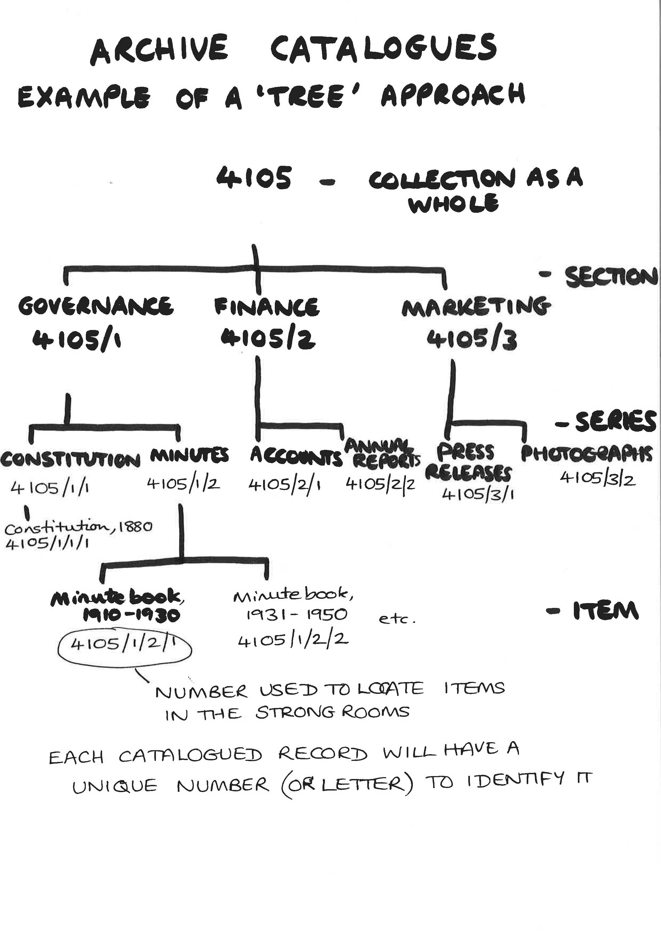
Because of this hierarchical nature of archival cataloguing, some of the information needed to help interpret a document may be found higher up the structure. This presents challenges particularly when using computerised catalogues where the researcher may expect to find everything they need within the immediate results of a search. With archive catalogues this simply may not be true – it is often necessary to look at an individual item in the context of its overall series and collection in order to understand it.
Archive catalogues may have been created long before computers so conventions which only work in a hard copy environment (such as putting ‘as above’ for similar items) may be carried forward into electronic versions of these same catalogues. It is the case, however, that archivists are very aware of this, and will be striving to correct it, and to make catalogue entries more ‘stand-alone’ than they may have been in the past.
- How to search
There is no ‘one size fits all’ approach to searching. Each individual repository will have its own approach to cataloguing and some will be further down the route of computerisation of those catalogues than others. Don’t forget that not everything is on-line – there may be old catalogues only available in typescript or index card form, and that collections which are not yet catalogued will also be missing from searches. Sometimes the records you want may simply not survive, but it is always worth double-checking with repository staff.
It is normally necessary to search within a specific dataset rather than simply ‘googling’ – ie you will need to go to the catalogue homepage for the repository in question, or a ‘hub’ of multiple repositories such as ‘A2A’ (see: www.nationalarchives.gov.uk/a2a) – and then search under the relevant fields shown. Normally there will be several fields available to search such as document title/description, date, and index fields such as person, place or subject. Try not to make your search too specific – it is better to start broad and then narrow it. You may find free text searching more successful than using specific fields.
You may have to think laterally about what search terms to use. For example, if I wanted to research prostitution in Victorian England, I would not get many ‘hits’ in a free text search of our archive catalogue if I simply put in ‘prostitution’ or ‘prostitute’, as only catalogue descriptions which specifically use that word will appear. I might have to search under related terms such as ‘venereal disease’, plus I might have to look more broadly under topics such as ‘crime and punishment’ or ‘policing’. Not every potential topic will be indexed. Archivists will be happy to give guidance on which collections will be most helpful for a specific topic, based on their knowledge and experience.
It is important to remember that the language used in catalogue descriptions reflects that in the original documents. These are not always ‘politically correct’ as they reflect the values of the society at the time of the documents’ creation, so for example you may find terms which are now considered simply derogatory (such as ‘imbecile’ or ‘idiot’) which actually had a precise medical meaning in the 19th century. Language is constantly changing and evolving its meanings so it is impractical for archivists to ‘police’ this, although we do try to be sensitive particularly where catalogues may relate to living people.

3. Towards A Collaborative Method (in progress)

